For this homework, I have found one survey which can be found on this page.

This survey is all about the effect of Artificial Intelligence on jobs. The survey obtained responses from three countries: the United Kingdom, the United States and Canada.

Here is an example of a question they asked

* *What do you believe an increase in the use of artificial intelligence means for jobs in your country?*

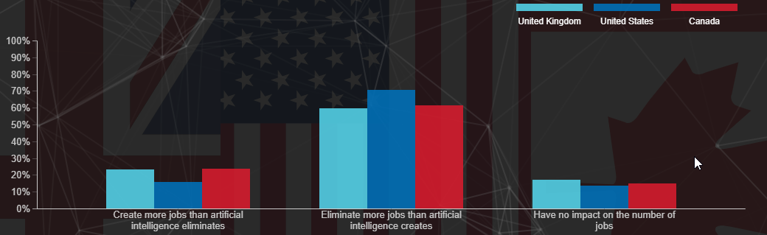

They conducted a survey of 10 000 people and this is the product of a single question, according to this report. In reality, this is a small problem, but it may demonstrate some possible negative effects on the transformation of employment into AI. Such AI-based robots can do any job if they are correctly designed and the error rate is as low as possible in the Machine Learning Model.

But, this causes another prejudice in most cases where people want to ease their jobs and give their routine tasks to the AI, of course, this would be fantastic, while others may think of the fact that many employees lose their jobs as soon as we get those smart machines.

I don't see any biases we've encountered in this survey, because this isn't a non-response bias, and we've got 2 left.Another is sample choice for convenience, and the other is voluntary choice.But you can see that the reason it's not voluntary is that 10,000 citizens in these countries have been picked either randomly or from different areas. This allows us to take this study into consideration with the comfort sample partition. Well, in fact, it's hazy until we know exactly where these surveys took place.But this might be the answer because they chose 3 out of 195 countries, but it makes sense because they are the most developed countries of the current era, I think.

So, to summarize the survey I have looked through, I would say Convenience bias might occur.

That’s all. Thank you!